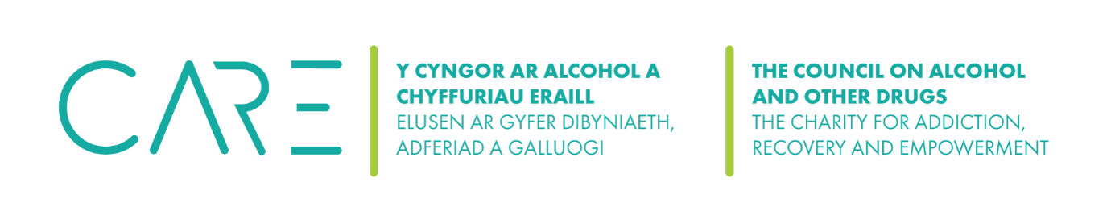
The Council on Alcohol and Other Drugs (CAOD)
Thank you for agreeing to be a trustee of the CAOD.
May I ask you to provide the following information please? This information is required for your details to be added to the Charity Commission website..
Very many thanks indeed for your help!

Information about all key people i.e. of all trustees together with the “account operators”
Full name
Personal Address
Previous Address (if moved in last twelve months)
Contact email
Contact phone number
Date of birth
Place of birth
Country of birth
Nationality

