
BE INFORMED – BE PREPARED – TAKE CONTROL
Guidance for an Emergency Box

GET INFORMED – BE PREPARED – TAKE CONTROL

If you have experienced self-harm or thoughts of suicide, you will recognize the feeling of being out of control and possibly reflect upon how you were unable to “think straight” at the time. There are incredibly good reasons for this, based on the research of what happens in your brain during times of heightened distress.
Along with our therapy sessions, I offer you this guidance for times when you feel most at risk of self-harm and suicide…to support you in being INFORMED of what is happening to you on a neuro-biological level, to help you to PREPARE for such times and to gain self-empowerment by bringing back your levels of CONTROL.
Creating your own personal EMERGENCY BOX at a time when you are feeling in control and focused on your own self-care, gives you the best opportunity to offer yourself safety and compassion during times of distress.
Below is a list of practical options you may want to collect for your emergency box:

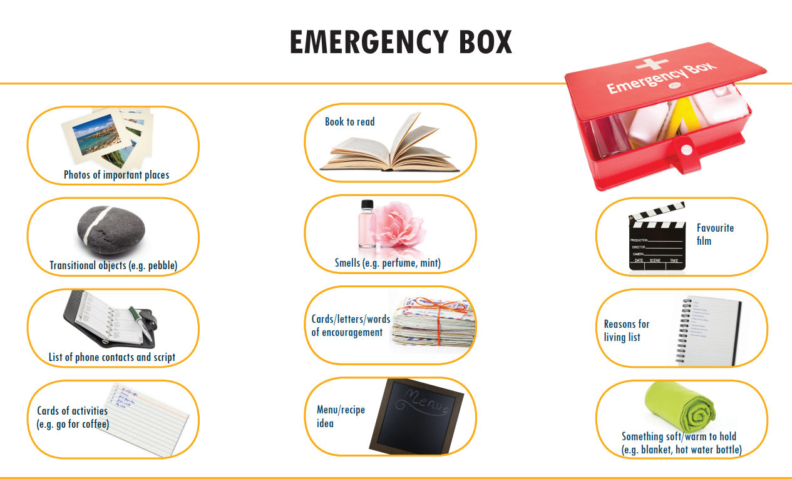

BEING INFORMED, PREPARED AND TAKING CONTROL
When you are feeling the compulsion to self-harm or have had suicidal thoughts, it can be difficult, if not impossible to see another way of ending the pain and despair you are feeling…the unbearable hopelessness and loneliness can often be so strong and relentless that you may feel you have no choice!
Once you have been in this unbearable, torturous place, it can become familiar or habitual to return there when feelings of distress become overwhelming…the brain remembers this, which puts you at greater risk!
Self-harm and suicide may feel like a solution to the agonising feeling you are experiencing, but really the problem is not self-harm or suicide, it is distress and the feeling that you will do absolutely anything to relieve this unbearable distress!
As your therapist, I am committed to allying myself with your goal of reducing your distress in the long-term. The fact that you have had thoughts of self-harm or suicide tells me that, if necessary, you will cause yourself injury or even die to relieve your distress, so I believe you are well motivated to do the work – because that is what the work consists of…relieving your distress!
If self-harm or suicide feel like your only choices, let me assure you they are not – you have a choice to get informed, be prepared, to take control and you have a choice to join life and make it a life you want to live. All these areas I will support you with, but the choice is yours to make!

GET INFORMED
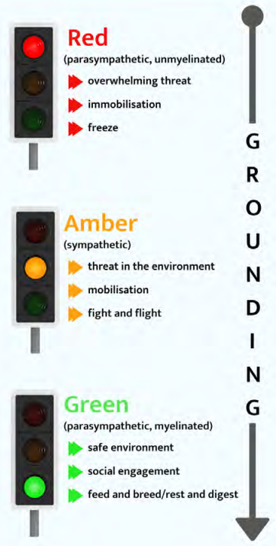
Changes occur in the brain when you are in heightened distress. Represented here in a traffic light system:
GREEN ZONE = safety
You are functioning well and making healthy, logical choices.
AMBER ZONE = threat response
You are in high agitation and anxiety, feeling the need to act and do something to ease the distress activating the fight or flight response.
RED ZONE = danger
The threat is overwhelming, and the brain wants to shut you off from the distress and pain.
Noticing the activation your fight or flight threat response in the AMBER ZONE, by recognising a rise in your levels of anxiety and agitation is where you can step in and avoid going into the RED ZONE by self-soothing back into the GREEN ZONE
INTERUPTING THE CYCLE OF SELF-HARM AND SUICIDAL THOUGHTS
Being informed about what is happening with your brain and how this can impair your ability to make choices to relieve your distress. It may not feel like you have control, but as the diagrams below indicate, you have the choice to interrupt the VICIOUS CYCLE OF SELF-HARM at stage 3 and begin the VIRTUOUS CYCLE OF SELF-SOOTHING.
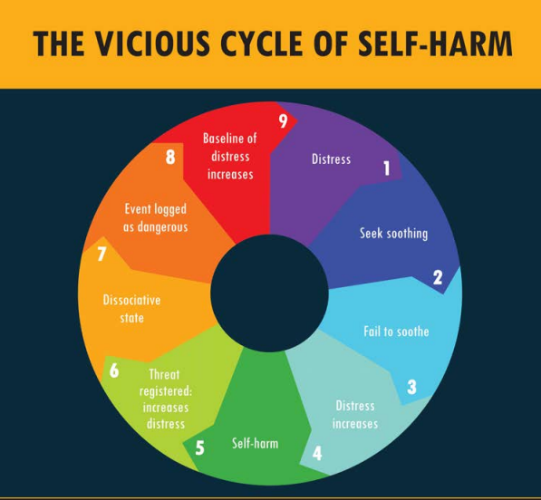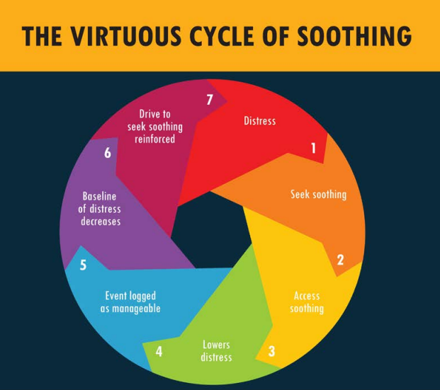
BE PREPARED
Our brain is a fantastic and complex organ – the FRONT is the conscious part where we have our control of language, planning, logic etc. The BACK is unconscious where it keeps everything working away so we don’t have to think about it – in essence, it keeps us alive!
However, when we are under distress, the brain receives a threat signal which switches the back brain into THREAT RESPONSE. At this point the front brain goes offline and we have impaired use of brain function.
This is our built-in survival mechanism – our back brain is solely concerned with keeping us from harm and keeping us alive. And we are grateful for it, if a tiger attacks us, we don’t have time to think or plan or talk him out of it…we must act!
Problems arise with our threat response when it is triggered by life events, memories, and trauma response – times when we need to be responsive in a logical and meaningful way to self-sooth.
When you are in threat response, you are in the AMBER ZONE, this is the time to use the information you have gained and prepare to get back into the GREEN ZONE.
Below is the information you need about impairments to your brain function and how to prepare to get your front brain back online and take control!
THE FRONT BRAIN
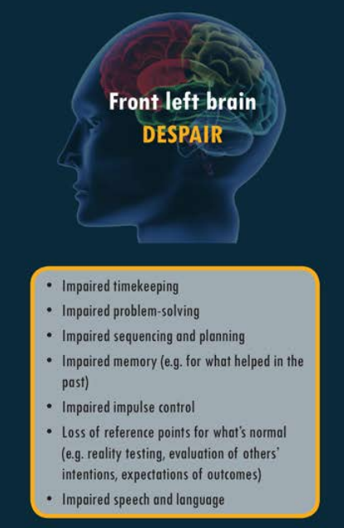

Impaired timekeeping
Impaired problem solving
Impaired planning / sequencing
Impaired memory
Impaired impulse control
Lack of normality reference point
Speech and Language

- LIST OF UPCOMING PLANS / FUTURE GOALS – click your brain out of the unending present despair and into the future (daily/ monthly/ seasonally) what do you want to see/ learn/ enjoy.
- PROBLEM SOLVE THE DISTRESS – create a list of strategies which have helped you in the past.
- PLAN YOUR RECOVERY – list what you will do when the feeling passes / make a to do list.
- REMEMBER WHEN YOU DIDN’T FEEL LIKE THIS – photos / souvenirs / letters/ vision boards/ bucket list.
- STEP BACK FROM YOUR EMOTIONAL REACTION – list of reminders of control, e.g., you feel like this now, but this will pass as it has before, or there is no need of action, or breathe through the feeling.
- REALITY CHECK – identify where your mind goes haywire; list reminders of the unknown outcome of a suicide attempt/ list the kind things people have said to you and how much you mean to them.
- KEEP SPEECH & LANGUAGE HAPPENING – list people to reach out and talk to, including emergency numbers, write in a journal, or read to activate your language and communication.

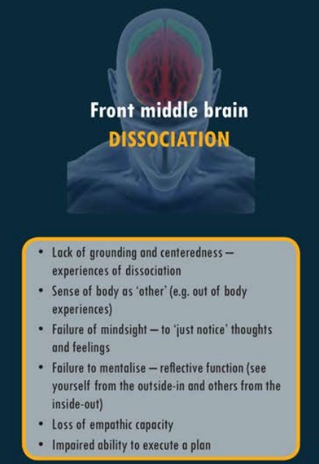

Lack of grounding & centeredness
Sense of your body as ‘other’
Failure to notice thoughts & feelings
Failure to mentalize – reflective function
Loss of empathic capacity
Impaired ability to execute plans

- FIND A FAMILIAR PLACE OF SAFETY – list places where you can go to feel safe and centred.
- RECONNECT WITH YOUR BODY – engage your mind with your bodily sensation. Have some soft toys, blankets, or a pillow. Keep some special food or treats.
- OBSERVE, DON’T REACT – Take note of what you are thinking and feeling; keep sheets to write down what is going on for you at this moment. Practice deep breathing and mindfulness.
- REMEMBER WHO YOU ARE – list what you bring to life and to others.
- REMEMBER WHO LOVES YOU – switch your empathy back online by thinking of how your loved ones would feel if you were no longer in their lives.
- MAKE A CHOICE – tea or coffee, pick which chair to sit in, use a pen or pencil; anything to click back online your ability to choose and remember you have the control.
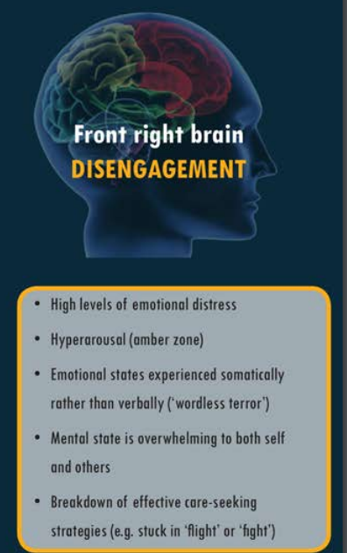

Elevated levels of emotional distress
Hyperarousal (amber zone)
Non-verbal states of emotion
Mental state overwhelming yourself and others
Stuck in fight or flight – breakdown of effective care

- FIND SOMEONE YOU TRUST – There is only one thing to remember when your front right brain goes offline; ENGAGE!
When you are suffering in the terror of self-harm / suicide mode, the fight or flight threat response is highly active, impairing your ability to relate to others in a way that is effective for your care. You may act aggressively, or childlike in fight mode, which can activate the fight mode on others…or you may disconnect and retreat from others in flight mode.
For this reason, it is crucial that you prepare for these impairments in advance when you are mentally capable of caring for yourself.
- List numbers and email addresses of trusted people you can connect with
- List emergency phone numbers
- Tell your trusted people in advance that what you require from them at this time is simply to talk…not to fix, only to talk.
Write a script for what to say when you call.

TAKE CONTROL
This is where you can take control and choose how you relieve your distress. I am here to support you with contact details, lists and guidance. I can’t do the work for you, but we can work in collaboration to discover how not only to survive, but to thrive in the life that you choose for yourself.

SERVICE | CONTACT DETAILS
GP
NHS 24 | 111  www.nhs24.scot
NHS GRAMPIAN | 0500 20 20 30
SAMARITANS | 116 123  01224 574 488  jo@samaritans.org
BREATHING SPACE | 0800 83 85 87  www.breathingspace.scot
PENUMBRA | Aberdeen: 0800 234 3695  Aberdeenshire: 0800 135 950  Text: 07768 647723  www.penumbra.org.uk  Email: aberdeen1stresponse@penumbra.org.uk
PAPYRUS  Prevention of Young Suicide | 01925 572 444  Text: 07786 209 697  Hopeline: 0800 0684 141  Email: pat@papyrus-uk.org
CHOOSE LIFE | www.chooselife.net
COMPASSIONATE FRIENDS | 0345 123 2304
COMBAT STRESS  Veterans Mental Health Charity | 0800 138 1619  www.combatstress.org.uk
SHOUT | Text: 85258

TRUSTED PEOPLE / SAFE PLACES
TRUSTED PERSONS | CONTACT DETAILS | SAFE ADDRESSES

SCRIPT TO THE PERSON(S) YOU TRUST
This script can be in a draft email or text, but as personal engagement is key to bringing yourself back into the GREEN ZONE and knowing language and communication will be impaired, it can be essential to refer to your script in order to communicate the danger to a trusted person(s).
Example:
I am at risk of harm, please talk to me and support me to get back to a safe place…….

REMEMBER WHO YOU LOVE AND WHO LOVES YOU
Switch your empathy back online and remember who loves you and wants you to live. Remember the kind, loving words you have heard from others – remember the kind, loving words you have said to others when they were in distress.

RECONNECT WITH YOURSELF
List of Bodily Sensation Words to reconnect with yourself and how your thoughts and feelings are presenting in your body. Remember, just observe what is happening with your body, feelings, and thoughts…there is no need to take action on this.

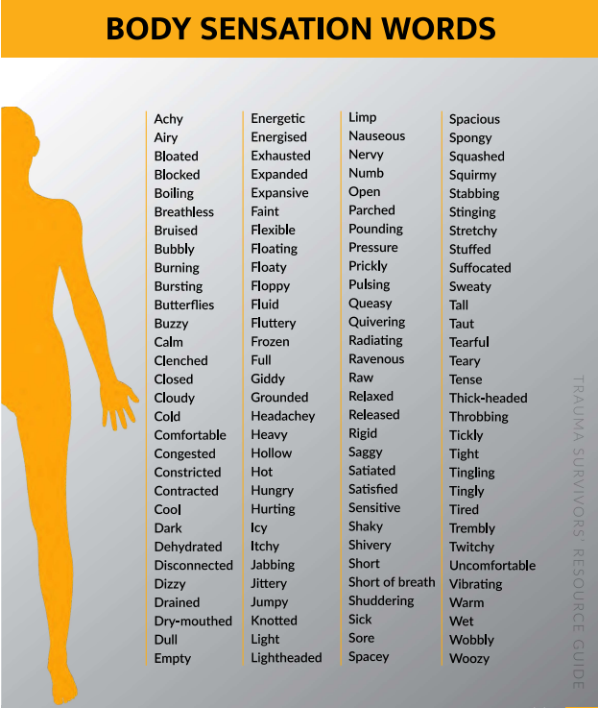

IDENTIFY YOUR EMOTIONS
Connect your bodily sensations with your emotional reaction to create a distance between what you are feeling and how you act…this gives you a window for choice.

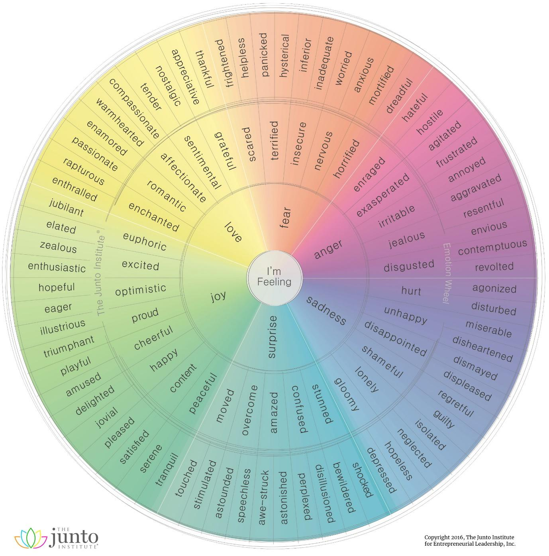

WHAT IS HAPPENING IN MY BODY? – WHAT AM I FEELING? – HOW AM I THINKING?

BODILY SENSATIONS | FEELINGS | THOUGHTS
REMEMBER YOU HAVE A FUTURE
Kick start your timekeeping capacity to bring yourself out of the depth of this moment and remember your future. List any upcoming events, tickets you have bought, events in your diary. What do you hope to achieve, what would you like to be around to see…

PLAN YOUR RECOVERY
How will you do when this feeling passes…make a to do list.

REMEMBER WHO YOU ARE
Make a list of what you bring to the world, what is important to you

REALITY CHECK
Suicide may feel like a quick solution, but the outcome is unknown. Think about the damage this may do to your body, your life, and your loved ones.

NOTES / JOURNALS

NOTES / JOURNALS

NOTES / JOURNALS

