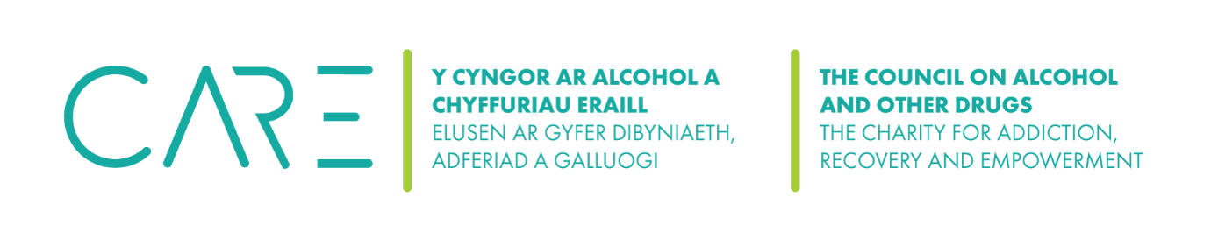
The Council on Alcohol and Other Drugs (CAOD) Environmental Policy

1. Introduction and purpose
The CAOD recognises that it has a responsibility to the environment beyond the legal and regulatory requirements. We are committed to reducing our environmental impact and continually improving our environmental performance as an integral part of our strategy and operating methods.

2. Responsibility

The CAOD is responsible for ensuring that this environmental policy is implemented, however, all employees, and volunteers have a responsibility in their area to ensure the aims and objectives of this policy are met.

3. Policy Aims

We endeavour to:
- Comply with all relevant regulatory requirements;
- Continually improve and monitor environmental performance;
- Continually improve and reduce environmental impacts;
- Incorporate environmental factors into the Charity’s business decisions;
- Increase employee awareness.

Paper
We will endeavour to:
- Minimise the use of paper within our services;
- Reduce the amount of printing that takes place within the organisation;
- Increase the use of electronic storage of documents;
- Reduce the amount of packaging as much as possible;
- Recycle paper and where possible where documents are not confidential use as paper for other activities.

Energy & Water
We will seek to:
- Reduce the amount of energy used as much as possible;
- Switch off lights and electrical equipment when not in use;
- Reduce water usage.

Office Supplies (including IT equipment)
We will:
- Evaluate if the need can be met in another way;
- Evaluate if renting or sharing is an option before purchasing equipment;
- Purchase recycled materials, including furniture where possible;
- Purchase second-hand furniture and equipment where possible;
- Only use a licenced IT recycling company when disposing of equipment;
- Sell or donate equipment where possible.

Transportation
We will:
- Reduce the need to travel, restricting to necessary trips only;
- Promote the use of travel alternatives such as emails, or electronic meeting platforms;
- Promote public transport and car sharing.

Furniture
We will:
- Locally source as much of the furniture for our rooms;
- Where possible source furniture that is environmentally friendly or the company has a robust environmental policy;
- Recycle or donate old furniture where possible.

Contractors
We use NHS approved contractors for the refurbishment of rooms. However, we do expect contractors wherever possible to:
- Produce their own environmental policy and any waste management licenses;
- Use environmentally friendly materials;
- Only purchase materials that are required;
- Not stockpile products as they may go out of date before use;
- Dispose of products and waste in line with regulatory requirements and manufacturers’ instructions; purchase environmentally friendly products and containers wherever possible.

Monitoring & Improvement
We will:
- Comply with all relevant regulatory requirements;
- Continually improve and monitor environmental performance;
- Continually improve and reduce environmental impacts.

Culture
We will:
- Update this policy at least annually or as necessary, in consultation with staff and stakeholders;
- Raise staff awareness of this policy and environmental concerns

Date | Changes made | Review date
 | Adopted

