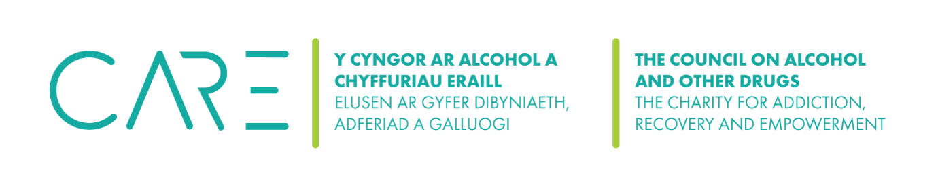
The Council on Alcohol and Other Drugs’ (CAOD) Conflict of Interest Policy

All Trustees and volunteers of the Council on Alcohol and Other Drugs (CAOD) will strive to avoid any conflict of interest between the interests of the Organisation on the one hand, and personal, professional, and business interests on the other.

This includes avoiding actual conflicts of interest as well as the perception of conflicts of interest. The purpose of this policy is to protect the integrity of the Organisation's decision-making process, to enable our stakeholders to have confidence in our integrity, and to protect the integrity and reputation of volunteers and Trustees.

What a Conflict of Interest is.
The Charity Commission’s guidance publication CC29 defines Conflicts of Interest as: “any situation in which a trustee’s personal interests or loyalties could, or could be seen to, prevent them from making a decision only in the best interests of the charity.
”Conflicts of interest: a guide for charity trustees:
https://www.gov.uk/government/publications/conflicts-of-interest-a-guide-for-charity-trustees-cc29/conflicts-of-interest-a-guide-for-charity-trustees

Examples of conflicts of interest include:
1. A Trustee who is also a user who must decide whether fees from users should be increased.
2. A Trustee who is related to a member of staff and there is a decision to be taken on staff pay and/or conditions.
3. A Trustee who is also on the Board of another organisation that is competing for the same funding.
4. A Trustee who has shares in a business that may be awarded a contract to do work or provide services for the organisation.

Upon appointment each Trustee will make a full, written disclosure of interests, such as relationships, and posts held, that could potentially result in a conflict of interest. This written disclosure will be kept on file and it will be updated as appropriate.

In the course of meetings or activities, Trustees will disclose any interests in a transaction or decision where there may be a conflict between the organisation’s best interests and the Trustees’ best interests or a conflict between the best interests of two organisations that the Trustee/s is/are involved with.

*Option 1: After disclosure, I understand that I may be asked to leave the room for the discussion and may not be able to take part in the decision depending on the judgement of the other committee members present at the time.

*Option 2: After disclosure, I understand that I will be asked to leave the room for the discussion and will not be able to take part in the decision.

Any such disclosure and the subsequent actions taken will be noted in the minutes. This policy is meant to supplement good judgment, and staff, volunteers and Trustees should respect its spirit as well as its wording.

Date adopted: January 2025
* Choose which option you prefer.

Signed by trustee ……………………………………………………..

Date | Changes made | Review date
January 2025 | None

