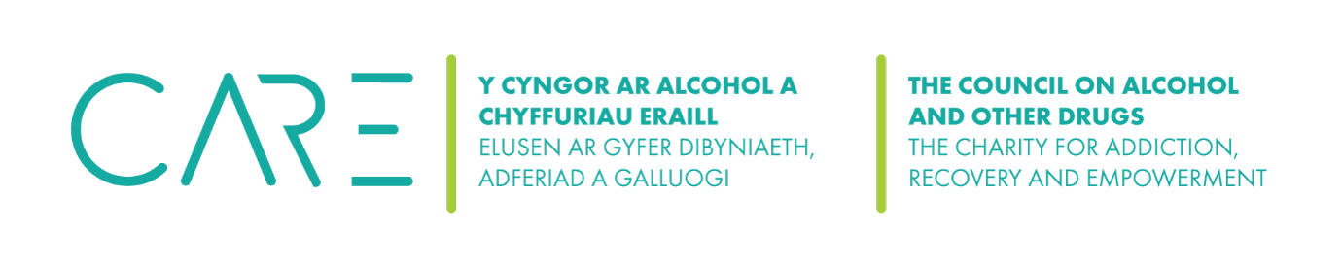
Professor Colin VE Powell, Honorary Professor of Child Health, School of Medicine, Cardiff University
Experience
I have been a Consultant Paediatrician for over 25 years and have been actively involved in child protection and safeguarding vulnerable young adults. I have always had level three children protection training and indeed been a level 3 child protection trainer. I have recently updated my Level 3 child and adult safeguarding training certificates attached.
Current Qualifications:
MB, ChB, DCVH, MRCP(UK), FRACP, FRCPCH, MD
Level three training: Virtual College by Netex adult and child safeguarding
18/02/2025
As you can see from the above qualifications, I am committed to keeping my qualifications up to date and ensuring I understand the any new legislation that brought in. I attend any briefings on legislation as necessary. Any new procedures etc are immediately passed on to clients, and staff.
Role description
The Designated Safeguarding Person’s role is to ensure that policies and procedures are followed and that staff/volunteers are trained and understand their role in respect to safeguarding. When issues or concerns arise the DSP’s role is to put into place the reporting procedures and review procedures.
My role will be:
- First point of contact for staff/volunteers if a concern is raised.
- To ensure the person raising the concern is supported through the process and that they follow procedures.
- Ensure all relevant documentation is gathered.
- To determine if there needs to be a report made to the authorities and to make that report.
- If a complaint is made against a member of staff or volunteer to ensure the person is suspended and to undertake an investigation.
- To write a full report of the investigation and where there is a concern then to report to the authorities.
- To follow up any reports made and to attend any meetings if required.
Reporting back to the board
Any safeguarding issues or concerns will be reported to the board, however the information provided will not contain details due confidentiality. The Board will be notified of any outcomes to investigations and any recommendations, updates to the policy or changes in legislation.
Fees
£25 per hour for any work completed on your behalf.

Contact Tele: 07967443659
Email: Cvep18@gmail.com

