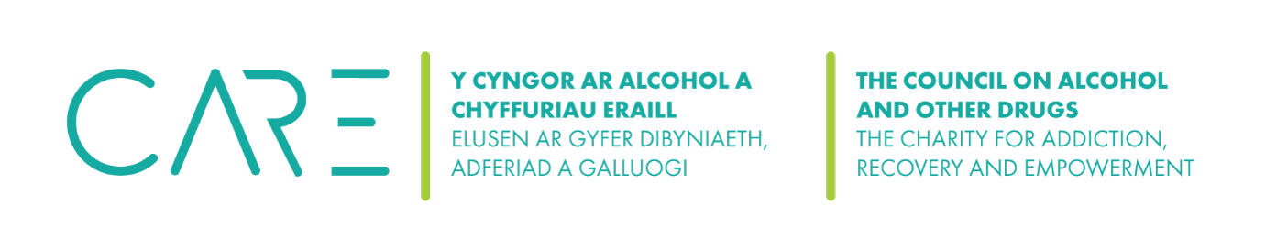

Suicide Risk Assessment and Safeguarding Procedures

The CAOD has comprehensive procedures for suicidal ideation risk assessment and safeguarding to establishing clear protocols, maintaining consistent documentation and follow-up practices in accordance with Addiction Professionals’ guidelines.
Counsellors and staff are required to be familiar with the following information and procedures detailed in this document:

Responding to Suicidal Ideation

Suicide Risk Assessment

Assessing level of Intent

Safety Plan

Further Actions

Summary: MAC Suicidal Ideation Procedures

Appendix

1) Responding to Suicidal Ideation
How to embark on a clear and open discussion about suicide will be informed by several factors, such as age, understanding or emotional capacity of the client and the individual approach of the counsellor.
Direct question: Asking clients whether they feel so low that they are considering taking their own lives can communicate to the client that the thought of suicide is something that the counsellor is able to hear. Clients can often perceive this as ‘permission’ to voice their most difficult feelings and thus begin to explore their suicidal thoughts as the therapeutic work progresses. Additionally, exploring with clients how they are able to keep themselves safe or ways in which they are able to manage suicidal thoughts can help them reflect further on the meaning of their feelings.
Mental capacity: Determining the ‘capacity’ of a client is difficult and often only clarified with the involvement of specialist mental health services. While counsellors and psychotherapists are not expected to undertake an in-depth assessment, in making judgments about the safety of the client and possible referral to a GP or mental health services, the counsellor needs to be able to demonstrate that they have carefully considered the client’s right to autonomy and confidentiality against the risk of suicide presented in the session.

2) Suicide Risk Assessment
Suicide risk refers to a broad range of behaviours, thoughts, or acts that may suggest an increased risk of death by suicide. How therapists assess, explore and therapeutically work with suicide risk may differ considerably according to how this presents in the therapy room.
Suicide risk in therapy can range from clients expressing abstract thoughts about ending their life, clear intent and plans about ending their life, or acts of self-harm and attempted suicide. As such, counsellors need to be prepared to therapeutically explore and work with different types of suicide risk.
Safeguarding for clients expressing thoughts of self-harm, hopelessness, worthlessness, or planning for suicide should be considered at risk. The following guidelines for risk assessment can be found in the CAOD’s Suicide Ideation Doc which must be completed as part of your risk assessment, and attached to your client’s Writeupp file:
- Ask the client directly if they are actively suicidal.
- Level of intention and intensity of suicidal thoughts (section 2)).
- Utilise standardised risk assessment tools, if necessary, in accordance with BACP guidelines (see appendix (a)).
- Frequency of suicidal thoughts.
- How long do these thoughts last for?
- Has the client planned how they might end their life?
- Has the client started preparation to carry out their plan?
- Does the client have the means to carry out their plan?
- Have there been previous attempts?

3) Assessing Level of Intent
Sometimes suicidal thoughts can be fleeting and general in nature, while for others suicide is a constant, intrusive idea. Talking more about suicidal feelings will begin to help clients, as well as practitioners, gain insight into the client’s level of intent.
Rate intensity: Asking clients to rate the intensity of their suicidal thoughts can be useful. Offering a 0–10 scale (where 0 equals no intention to act and 10 equals an immediate intention to act) can help in the process of understanding the immediacy of risk.
Protective factors: One of the most significant resources in managing suicidal ideation and assessing intent is the presence of protective factors. Asking clients how they have kept themselves alive and in what ways they have prevented themselves from acting on their suicidal thoughts might help to develop or reinforce future coping strategies. A client’s unwillingness or inability to continue to identify and use such strategies might indicate that they are no longer able to keep themselves safe.
Examples of questions for clients in assessing Protective Factors against suicidal ideation:
- "Who are the people you can talk to when you’re feeling down or stressed?"
- "Who or what do you feel a strong sense of responsibility towards?"
- "Can you tell me about something you’re looking forward to or working towards?"
- "What are some of the goals or dreams you have for the future?"
- "How does your role as a (parent, caregiver, employee, etc.) influence your daily life?"
- "Can you describe a time when you successfully managed a tough situation?
- "Can you tell me about a recent accomplishment that made you feel proud?"
Accessible support: What support might be available to suicidal clients outside therapy is crucial. Equally important is the client’s willingness or ability to access such support when needed. If a client does not feel able to contact support at times when they have suicidal thoughts, it is necessary to help them consider factors that might make using such support more likely. If the client is not able to consider ways in which they could use support when suicidal feelings are most intense then concerns might be increased about their level of intent and ongoing safety:
- Friends or family: contact list of safe people and places in times of crisis.
- Mental health support: CPN / GP Practice / Mental Health Professionals.
- Out of hours crisis lines (Appendix (b)).
By discussing their suicidal feelings and thoughts and how they might react to them in detail with clients, the counsellor is better placed to work with them in thinking about future safety. All decisions should, wherever possible, be collaboratively agreed with the client and be acted on in the context of the client’s explicit, written consent. That might include continuing to work within the boundaries of the confidential therapeutic relationship or discussing concerns with other people with or without the client’s permission depending on the level of risk and intention.

4) Safety Plan
A suicidal safety plan is a personalised and collaborative strategy designed to support individuals experiencing suicidal thoughts. The primary aim is to provide immediate and practical steps to enhance their safety, reduce the risk of self-harm, and offer a structured approach for coping with crises. This plan is developed with the active involvement of the client and, when appropriate, includes input from their support network. It is a crucial tool for ensuring the well-being of clients and fostering a sense of hope and empowerment.
Safety Plan Objectives:
- Written collaboratively and encourage self-empowerment – unwillingness to engage may indicate a level of risk which requires further action.
- Be responsive to the client’s age and understanding.
- Focus on specific risk factors – what factors make suicidal ideation more or less likely.
- Identify danger times when risk may be greater.
- Notice early warning signs.
- Explore protective factors.
- Create a support network both formal and informal – list contact details and safe places.
- Offer a presence outside of session – agree boundaries with on communication with the counsellor.
- Encourage ownership of the safety plan.
- Be inclusive of the safety plan – sharing with others of possible or appropriate.
- Agree on regular review of the safety plan.

5)Further Actions
Deciding to disclose information about concern to a third party, such as a GP or crisis team remains one of the most difficult decisions for counsellors. Such decisions need to be made collaboratively; another person’s perspective can be vital in ensuring such decisions are made in the best interests of the client, rather than in response to counsellor anxiety.
Disclosure to a third party: If the counsellor feels that despite talking things through, the client remains at immediate risk to themselves and is unwilling or unable to consent to the disclosure of information to a third party, it is important that the counsellor acts on their concerns quickly and appropriately:
Report: Immediate concerns of risk and intent must be discussed with our CEO: Wynford Ellis Owen – wynfordellisowen@hotmail.co.uk (07796464045), if he in unavailable, contact our administrator ….. Counsellors and management will discuss the appropriate actions.
All information pertaining to a client's suicidal ideation, risk assessment, and safety plan must be treated with the utmost confidentiality in compliance with Addiction Professional guidelines and data protection laws.

.

Supervision: Counsellors at the CAOD are encouraged to seek supervision and consultation with the clinical director or external supervisors when managing clients with suicidal ideation. Consultation with a supervisor in the event of immediate concern over a client can be invaluable in helping the practitioner to remain client-centred rather than anxiety-driven and to ensure a holistic and safe approach to supporting clients in distress.
Suicide awareness training: Counsellors and staff have a responsibility to be trained in suicide awareness and keep up to date with developing research and ethical guidelines.

6) Summary: The CAOD’s Suicidal Ideation Procedures
By following these procedures, counsellors at the CAODg can effectively assess and support clients experiencing suicidal ideation while upholding ethical standards and promoting client safety and well-being.
- Directly ask your client if they are experiencing suicidal ideation.
- Assess age concerns and mental capacity.
- Assess risk level.
- Assess suicidal intention level.
- Collaborate to create a safety plan.
- Report to Wynford Ellis Owen.
- Document the session and your actions using: the CAOD’s Suicide Safeguarding doc, and attach to you client’s Writeupp file.
- Review and update regularly.

7) Appendix

(a) C-SSRS

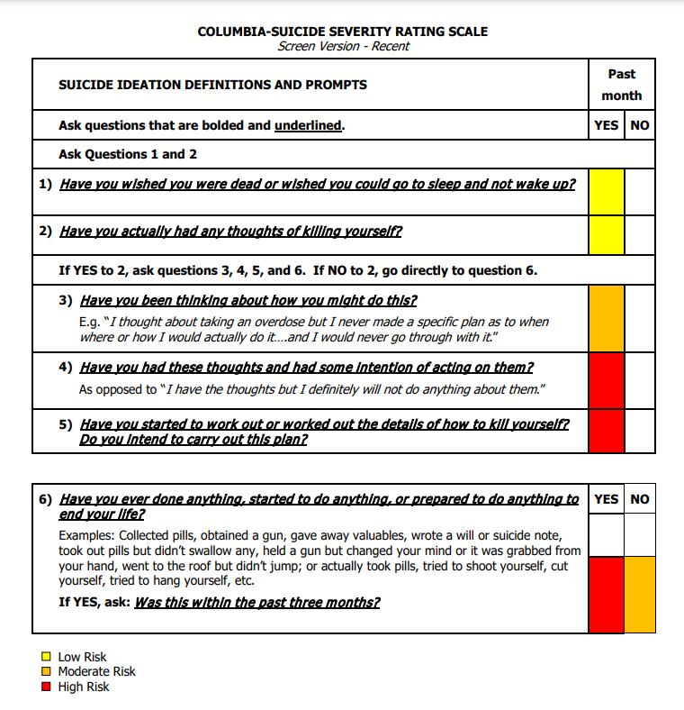

(b) Crisis Helplines and Support

National Helplines
- Samaritans
  - Phone: 116 123 (24/7)
  - Website: www.samaritans.org
  - Description: Provides confidential emotional support to anyone in distress or experiencing suicidal thoughts.
- NHS 24
  - Phone: 111 (24/7)
  - Website: www.nhs24.scot
  - Description: Provides urgent health advice and mental health support.
- Childline
  - Phone: 0800 1111 (24/7)
  - Website: www.childline.org.uk
  - Description: Offers free and confidential support to children and young people.
- Shout Crisis Text Line
  - Text: SHOUT to 85258 (24/7)
  - Website: www.giveusashout.org
  - Description: A free, confidential, 24/7 text messaging support service for anyone in crisis.
- HOPELINEUK (PAPYRUS)
  - Phone: 0800 068 4141 (9 am - midnight every day)
  - Text: 07860 039 967
  - Email: pat@papyrus-uk.org
  - Website: www.papyrus-uk.org
  - Description: Provides confidential support and advice to young people struggling with thoughts of suicide, and anyone worried about a young person.
Regional Helplines
- Saneline
  - Phone: 0300 304 7000 (4:30 pm - 10:30 pm every day)
  - Website: www.sane.org.uk
  - Description: Offers emotional support and information to anyone affected by mental health problems.
Specialised Support
- Survivors of Bereavement by Suicide (SOBS)
  - Phone: 0300 111 5065 (9 am – 9 pm every day)
  - Website: www.uksobs.org
  - Description: Provides support to those who have been bereaved by suicide.
- Combat Stress Helpline
  - Phone: 0800 138 1619 (24/7)
  - Text: 07537 404 719
  - Email: helpline@combatstress.org.uk
  - Website: www.combatstress.org.uk
  - Description: Provides confidential help and advice on mental health issues for the military community.
Online Resources
- Mental Health Foundation
  - Website: www.mentalhealth.org.uk
  - Description: Offers information and support for various mental health issues.
- YoungMinds Crisis Messenger
  - Text: YM to 85258 (24/7)
  - Website: www.youngminds.org.uk
  - Description: Provides free, 24/7 text support for young people experiencing a mental health crisis.

