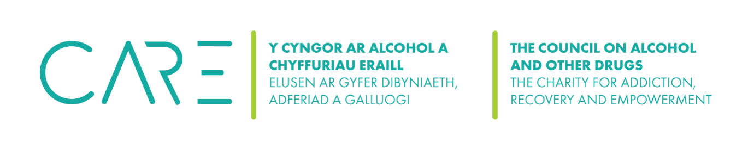
Confidential Session Notes
Date of session:

Presenting issue:

Interventions used & rational behind it:

Clients progress/positive changes:

Action plan/goals:

Referrals or consultations:

Risk assessment/safety issues:

Any other relevant information:

