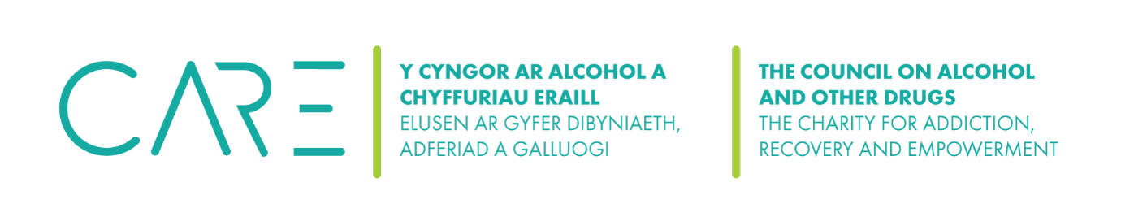
Safeguarding Adults
It is important for people working in the health and social care sector to be aware of safeguarding adults.
arrow_drop_down
The Care Act (2014) gives a legal framework for safeguarding adults. Other important legislation on safeguarding includes:
- Equality Act 2010
- Safeguarding Vulnerable Groups Act SVGA (2006)
- The Human Rights Act 1998
- The Mental Capacity Act 2005
Organisations involved in the caring sector should have policies and procedures on safeguarding adults.
Definition of ‘an adult at risk’
In safeguarding terms an adult at risk is defined as a person 18 and over who:
- has needs for care and support (whether or not the local authority is meeting any of those needs) and;
- is experiencing, or at risk of, abuse or neglect; and
- as a result of those care and support needs is unable to protect themselves from either the risk of, or the experience of abuse or neglect.
An adult does not need to be in receipt of a care or support delivered by the local authority.
What is abuse?
The Care and support statutory guidance identifies ten types of abuse, these are:
- Physical abuse
- Domestic violence or abuse
- Sexual abuse
- Psychological or emotional abuse
- Financial or material abuse
- Modern slavery
- Discriminatory abuse
- Organisational or institutional abuse
- Neglect or acts of omission
- Self-neglect
Abuse can happen anywhere and can consist of single or repeated acts. An abuser can be anyone that comes into contact with an adult at risk person and is often someone well known to them.
Safeguarding Adults Boards
The Care Act (2014) requires that Safeguarding Adults Boards (SABs) are overseen by each local authority, consisting of experts from various fields such as health professionals, police, social care services, housing, and voluntary agencies.
SABs have three core duties. They must:
- develop and publish a strategic plan setting out how they will meet their objectives and how their member and partner agencies will contribute
- publish an annual report detailing how effective their work has been
- commission safeguarding adults reviews (SARs) for any cases which meet the criteria for these.
Each Local Authority will have mechanisms in place to respond to adult safeguarding concerns. These should be communicated to all local statutory, voluntary and community agencies and include clear policies and procedures for agencies to refer to.
Confidentiality and sharing information
All organisations should follow clear principles of confidentiality in relation to their service users. However there will be occasions when it is appropriate to share information about clients in order to protect their best interests and, therefore, you should never give assurance of confidentiality. It is a legal requirement that agencies and professionals work together regarding safeguarding issues.
- Make sure your organisation has clear policies on information sharing and that you have procedures in place around working with other organisations
- Only share information on a ‘need to know’ basis and when it is in the best interests of your service users.
- Always try to obtain informed consent from your clients before sharing information, however if this is not possible it may be necessary to override this requirement – especially if other adults are at risk. Staff should seek management support wherever possible to decide whether to share information without consent
The Data Protection Act (2018) allows organisations to share information about clients without their consent in some limited circumstances. They include:
- To protect the vital interests of an individual – the vital interests condition also extends to any other individual who might be impacted.
- Where the individual lacks capacity to give meaningful consent
Safeguarding alerts
As well as following Local Authority procedures, your organisation should have its own internal policies and procedures relating to adult safeguarding. While safeguarding procedures may vary slightly between agencies and local authorities, they should all follow the same fundamental process:
- Make sure the adult at risk is not in immediate danger. If necessary, seek urgent medical
- Contact the police if you think a crime has been committed or if someone is in immediate
- Raise a ‘safeguarding alert’ by informing your line manager or the designated safeguarding lead within your organisation.
- Make a written report recording your concerns and detailing anything you have seen including dates, times, and people involved. Make the report factual and avoid giving opinions.
Once a safeguarding alert has been raised, the designated safeguarding lead in your organisation will decide how to proceed with the concern. Action must be taken as soon as possible to minimise any risk of harm or exploitation to individuals concerned. In the absence of management support, raise an alert to the local authority. In the first instance this will often be via the local social services helpline or emergency duty team. Make sure you are aware of your your organisation’s whistleblowing policies and procedures, to be followed when reporting any safeguarding concern involving a colleague.
All safeguarding concerns should be fully investigated by social services. Social services may decide that they need to take no further action, or they may decide that an adult safeguarding plan is required, to stop the abuse and/or to manage the risks that have been identified. This will involve all agencies involved with the client, and will be reviewed every 6 months.
Training and continuing professional development
All practitioners and volunteers must be trained in safeguarding. Safeguarding training should be updated and refreshed regularly for all practitioners. Organisations should consider including safeguarding training as part of continual professional development (CPD) of staff and managers. CPD may include training but could also include many other development activities, for example: keeping a reflective journal or facilitating a discussion group or activity. A useful starting point for CPD activity is an organisation’s supervision and/ or appraisal process.
Resources and training
Social Care Institute for Excellence resource on adult safeguarding
Manchester Safeguarding Boards has a range of links to training and development resources
NSPCC has a useful resource on female genital mutilation
Virtual College on course on awareness of forced marriage
Open Learn – OU MOOC platform course on Modern Slavery

