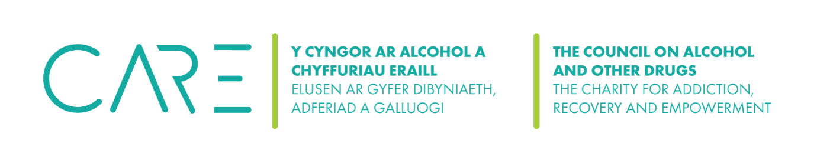
The Council on Alcohol and Other Drugs (CAOD) Summary of Policies - 2025

Policy | Date Approved | Review Date | Review Date | Comments
Code of Conduct (Trustees)

Conflict of Interest Policy (Trustees)

Recruitment, Induction and Appraisal Policy (Trustees)

Equal Opportunities Monitoring Form

Wellbeing Policy

Dignity Policy

Complaints Policy

Trustee and Volunteers Expenses Policy

Volunteers Induction Policy
Safeguarding

Digital Safeguarding Policy

Trustee / Volunteer Declaration

Manager Declaration

Equality of Opportunity

Environment Policy

Privacy Policy (website) (including GDPR)

Cookies Policy (website)

Cyber Security & IT Policy

Welsh Language Policy

Risk Management (including assessment and mitigation)

Health & Safety Policy and Procedures

Health & Safety Risk Planner

Financial Management and Controls Policy

Reserves Policy (for bids)
Donations Policy

Fundraising Policy

Social Media Consent Form

Social Media Policy

